A

Synopsis/Project Report

On

**House Marketing App**

Submitted in partial fulfillment of the requirement for the VII semester

**Bachelor of Computer Science**

By

**Suraj Adhikari**

**Surender Singh**

**Swapnil Tamta**

Under the Guidance of

**Mr. Ravindra Koranga**

**Assistant Professor**

**Department of CSE**



**DEPARTMENT OF COMPUTER SCIENCE & ENGINEERING**

**GRAPHIC ERA HILL UNIVERSITY, BHIMTAL CAMPUS**

**SATTAL ROAD, P.O. BHOWALI,**

**DISTRICT- NAINITAL-263132**

**2022- 2023**

**STUDENT’S DECLARATION**

We, **Suraj Adhikari, Surender Singh and Swapnil Tamta** here by declare the work, which is being presented in the project, entitled “**House Marketing App**” in partial fulfillment of the requirement for the award of the degree **B.Tech** in the session **2022-2023**, is an authentic record of my own work carried out under the supervision of “**Mr. Ravindra Koranga”, Assistant Professor, Department of CSE, Graphic Era Hill University, Bhimtal.**

The matter embodied in this project has not been submitted by us for the award of any other degree.

Date:

Suraj Adhikari

Surender Singh

Swapnil Tamta

**CERTIFICATE**

**The project report entitled “House Marketing App” being submitted by Suraj Adhikari, Surender Singh and Swapnil Tamta to Graphic Era Hill University Bhimtal Campus for the award of bonafide work carried out by them. They have worked under my guidance and supervision and fulfilled the requirement for the submission of report.**

**(Mr. Ravindra Koranga) (Dr. Ankur Bisht)**

**Project Guide (HOD, CSE Dept.)**

**ACKNOWLEDGEMENT**

We take immense pleasure in thanking Honorable **“Mr. Ravindra Koranga”** (**Assistant** **Professor,** **CSE, GEHU Bhimtal Campus**) to permit me and carry out this project work with his excellent and optimistic supervision. This has all been possible due to his novel inspiration, able guidance and useful suggestions that helped me to develop as a creative researcher and complete the research work, in time.

Words are inadequate in offering my thanks to GOD for providing me everything that we need. We again want to extend thanks to our President **“Prof. (Dr.) Kamal Ghanshala”** for providing us all infrastructure and facilities to work in need without which this work could not be possible.

Many thanks to Professor **“Dr. Manoj Chandra Lohani”** (Director Gehu Bhimtal),

other faculties for their insightful comments, constructive suggestions, valuable advice, and time in reviewing this thesis.

Finally, yet importantly, we would like to express my heartiest thanks to our beloved parents,

for their moral support, affection and blessings. We would also like to pay our sincere thanks to all our friends and well-wishers for their help and wishes for the successful completion of this research.

**Suraj Adhikari,**

**Surender Singh,**

**Swapnil Tamta**

**TABLE OF CONTENTS**

**Declaration…………………………………………………………………………..I**

**Certificate……………………………………………………………………………II**

**Acknowledgement…………………………………………………………………..III**

**Abstract………………………………………………………………………………IV**

**Table of Contents…………………………………………………………………….**

**List of Publications…………………………………………………………………..**

**List of Tables…………………………………………………………………………**

**List of Figures………………………………………………………………………..**

**List of Symbols……………………………………………………………………….**

**List of Abbreviations………………………………………………………………...**

**CHAPTER 1: INTRODUCTION……………………………………………**

* 1. Objective………………………………………………………
  2. Background and Motivations………………………………….
  3. Problem Statement…………………………………………….
  4. Objectives and Research Methodology……………………….
  5. Project Organization…………………………………………..

**CHAPTER 2: PROPOSED SYSTEM………………………………………**

2.1 History………………………………………………………...

2.2 ………

**CHAPTER 3: S/W AND H/W REQUIREMENTS (UP TO FULLEST EXTENT)**

**……………………………………………………………………**

3.1 S/W and H/W requirements (up to fullest extent)……………………

3.1.1 Security………………………………………………………………

3.2 Resources and Technology used……………………………………..

**CHAPTER 4: DFD (AT LEAST UP TO 2 LEVEL)……………………………….**

4.1 DFD (At least up to 2 level)…………………………………………..

**CHAPTER 5: DATABASE DESIGN (APPLICABLE IN CASE THE PROJECT HAS DBMS AT BACKEND)…………**

5.1 Database Design (Applicable in case the project has DBMS at backend)

…………………………………………………………………………

5.2 …………………………………………………………………………

**CHAPTER 6: ER DIAGRAM……………………………………………………….**

6.1 ER Diagram…………………………………………………………...

**CHAPTER 7: CODING OF FUNCTION…………………………………………..**

7.1 Basic modules of the project…………………………………………..

**CHAPTER : LIMITATIONS (WITH PROJECT)**

**CHAPTER : CONCLUSION**

**REFERENCES………………………………………………………...**

**PROJECT ABSTRACT**

House Marketing is the place where the owners can openly put their house for either sell or rent. And the customers can select the choices from various users according to their need of buying or being a tenant.

This project is based on the idea of creating a platform where various users can either sell or rent their property or buy or be a tenant at someone’s property. In this project we are going to do is the user can place his property or house at either for sell or rent and those customers who are in need of such property for buying or being a tenant can easily perform their action with just few clicks online. This project removes the need of the third party person who tell us about the property and charge us money for that in real life. This project will allow the working of real estate to work smoothly.

**INTRODUCTION**

This project is based on web and android application, the project “**House Marketing App**” will be used to solve the problem of requiring the third party user or bargainer for either renting or selling his/her property from owner side and buying or being a tenant in a property from the customer side. This project will help users to easily isolate their required choices according to their need and will complete their task easily.

Today’s modern and technical life has made everyone to complete their task in the tips of their fingers and this project tries to satisy that need of the user through which he/she can handle the real state work of buying or renting the house as easily as possible. This app allows the user to keep in touch with vaious houses or property that are for sell or rent and help them get the choice that they need.

In short and simple word this project is designed in such a manner to utilize the user’s time and give them maximum output to simplify their life.

Our project “**House Marketing App**” provide its functionality to three different users namely the OWNER, the CUSTOMER and the ADMIN. But the main focus is the OWNER and the CUSTOMER cause they are the ones putting their house for either rent or sell or buying the house or being a tenant. While the ADMIN has the similar authority as the OWNER and the CUSTOMER but also has some additional authority that allows the ADMIN to discard any property or prohibit a particular user if he/she misuses the app.

**OBJECTIVE**

The objective of making this project is to solve the problem of requiring the third party user or bargainer for either renting or selling his/her property from owner side and buying or being a tenant in a property from the customer side. And is based on the idea of creating a platform where various users can either sell or rent their property or buy or be a tenant at someone’s property. This app allows the user to keep in touch with vaious houses or property that are for sell or rent and help them get the choice that they need. This makes the workflow quite easier and simple to perform by an average human being.

**PROBLEM STATEMENT**

In today’s modern life the real estate business is growing day by day so as the need to buy multiple houses, property etc. Due to which various lives has changed and influenced.

Real estate business is **the profession of buying, selling, or renting real estate (land, buildings, or housing)**.

This business requires the buying and selling of houses in a very efficient and faster way so as to conserve the time of both the owner and customer.

As, we already know everyone requires shelter in this world to live a peaceful life without any hindrance. So, the need to buy or be a tenant at some place is further motivating the idea and the need of a platform where the users can sell or rent their property or house from the owners side and can buy or either be a tenant from customers side.

This work can be performed physically too, but many individuals don’t know the adequate process to follow to complete their task. Also there is the issue of scam by the third party person which can uprate the original price for its benefit.

**Project Organization**

We are 3 members in this project and contributing to this project as

* Suraj Adhikari
* Surender Singh
* Swapnil Tamta
* Suraj Adhikari is working on database & backend.
* Surender Singh is working on the front end & testing of the project.
* Swapnil Tamta is working on the front end.

**Present Status of development of project**

* Our all paperwork is completed.
* We completed the planning phase of application.
* Currently we are making on making a normalized database for our project.

**ER-Diagram**

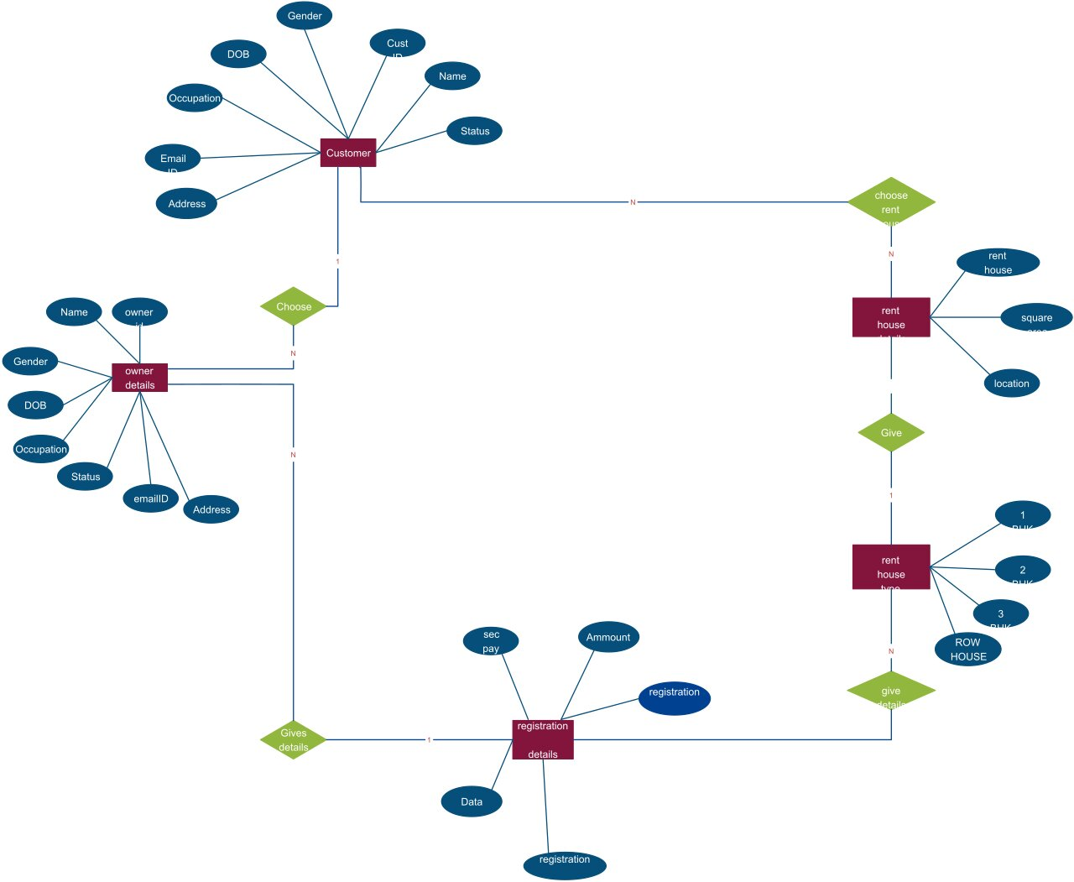

**Activity Diagram**

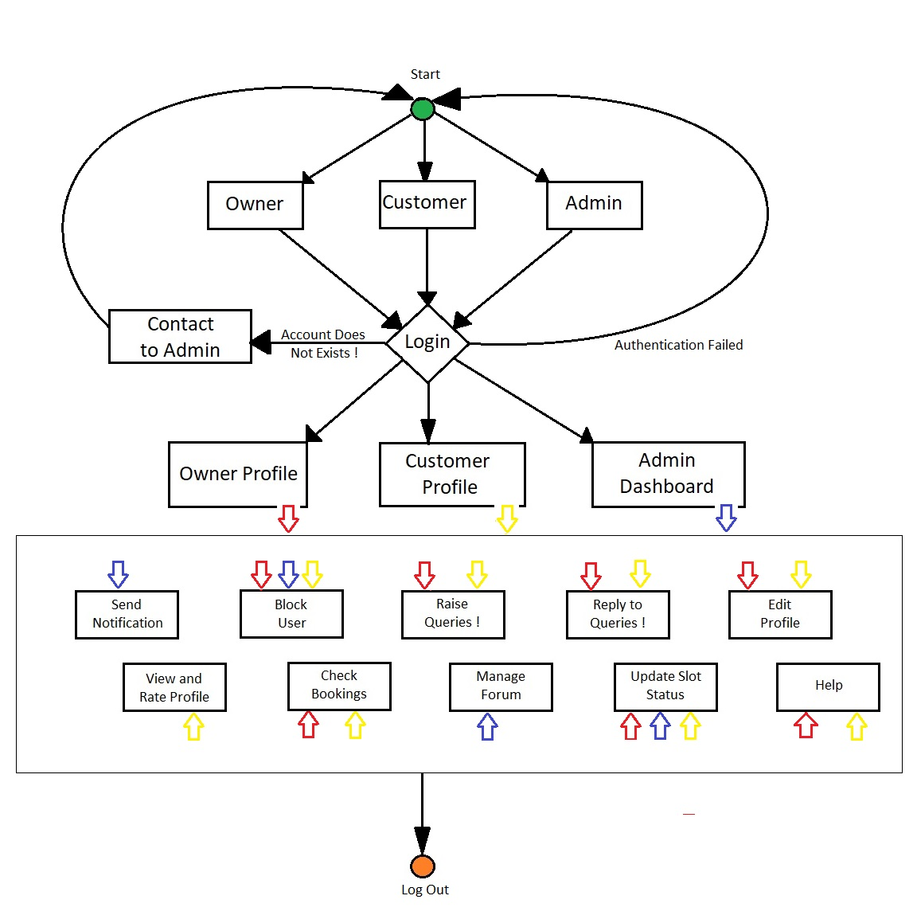

**Resources and Technology used**

**For making simple & attractive front-end :**

Our project will be a web application and it should be responsive for each accessible device.

Hence we are using these Technologies for making attractive front-end.

* **HTML 5:** Since it is a web application that has to be displayed in a browser and we know that browser display everything in the form of markup. HTML is a markup language that provides the structure of a website so that web browsers know what to show. That’s why we are using Hyper Text Markup Language (HTML);
* **CSS :** Cascading Style Sheets, commonly known as CSS, is an integral part of the modern web development process. It is a highly effective HTML tool that provides easy control over layout and presentation of website pages by separating content from design.
* **Bootstrap :** Bootstrap is a free and open-source front-end web framework for designing websites and web applications. It contains HTML and CSS-based design templates for typography, forms, buttons, navigation and other interface components, as well as optional JavaScript extensions. Unlike many web frameworks, it concerns itself with front-end development only.
* **JavaScript :** JavaScript is most commonly used as a client side scripting language. Here we are using for making good look and feel and mainly for validation purpose.

**For dealing with database(Backend) :**

* **Node.js:** Node.js is an open-souce server environment. It is a cross-platform and runs on Windows, Linux, Unix, and macOS. Node.js is a back-end JavaScript runtime environment. Node.js runs on the V8 JavaScript Engine and execute JavaScript code outside a web browser.
* **Database:** We are using google firebase as it supports IOS, Android, Web and Unity products, allowing you to track your users across a wide range of devices. Also it is cloud-hosted NoSQL database that lets you store and sync data between your users in realtime.
* **Editor:** VS Code, Postman

Since no application can be perfect, there may be some issues so we continously updating our application with new feature and trying to touch perfection.

**Basic modules of project**

Our project is divided into three modules:

* Owner
* Customer
* Admin
* The role of **OWNER** is to put their house or property for either sell or for rent according to his/her need. And the **OWNER** can also put discout on their respective property for a limited timeperiod.
* The role of **CUSTOMER** is to buy the owner’s property or be a tenant on his/her property according to his/her need. The **CUSTOMER** can go through various choices and options before selecting a house. Also there are various customizations available so that the users can get his/her required choice easily.
* The role of **ADMIN** is to manage all the things like which owners property to display first from rest or highlight some VIP users property so that they can get more customers apart from others. The **ADMIN** can also prohibit certain users and their accounts if there is a violation of rules by the user. Also, the **ADMIN**  has to go through the application every few days to check if the application is working properly and is bug free.

**CONCLUSION**

We are making a project on **House Marketing Place.** It has different benefits like:-

* The **OWNERS** can easily put their property or house for either sell or rent.
* Since we have already seen some similar applications, the thing that makes the difference is its unique and simple UI which makes it usable even for an average human being.
* The **CUSTOMER** can easily pick the house or property for either buying or for being a tenant and the transaction process is also very simple and efficient.
* It notifies the user as soon as possible or recommend him/her if any new property or house meets his/her need based on his/her earlier decisions.
* This project solve the problem of requiring the third party user or bargainer for either renting or selling his/her property from owner side and buying or being a tenant in a property from the customer side
* This project will help users to easily isolate their required choices according to their need and will complete their task efficiently.

We have seen the various advantages of this project which are helpful in the real-world scenario.

We will add several new features in the upcoming future to further benefit the user and make his life comfortable. And will try to further improve the UI exp so that every person can easliy access our website and use it to its best benefit.